Stop Drinks

Tracking Link:

SUBJ: death drinks

Preheader: If You Drink These, Stop Immediately

This isn’t a joke. It’s as serious as it can get.

If you are diabetic, pre-diabetic or know someone who is, keep reading.

Experts are pushing to get these 3 drinks moved over to the 'Do Not Consume' list asap.

These killers have been officially labeled the "Diabetes Death Drinks".

They are so dangerous that even consuming a small amount can trigger a deadly response.

Tap here to find out what the 3 deadly drinks are!

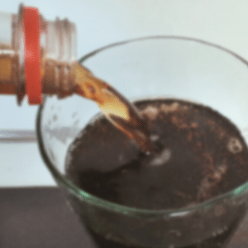

[Sign off]

P.s. Frequent consumers — defined as consuming two or more of these death drinks a day — had a 500% waistline increase over non-users, according to researchers.

