Fungus Hack Swipes

Subject: Put This Spice In Your Shoes To Fix Toenail Fungus Overnight
What I'm about to share with you right now will forever change the way you see toe nail fungus...
You're about to discover a simple natural spice that could FIX toe nail fungus overnight by attacking the true root cause of toe nail fungus in a way you have never seen before...

This toenail fungus discovery is leaving doctors speechless:

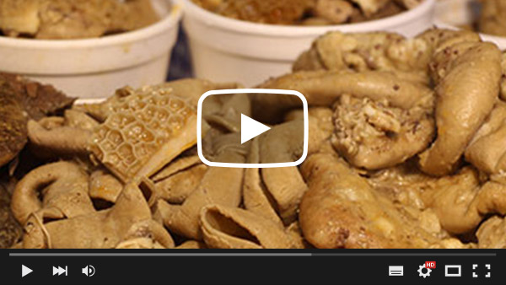

Put This Spice In Your Shoes To Fix Your Toenail Fungus Overnight
[SIGN OFF]

Subject: FIX Toenail Fungus Overnight With THIS
What I'm about to share with you right now will forever change the way you see toe nail fungus...

You're about to discover a simple natural hack that can FIX toe nail fungus overnight by attacking the true root cause of toe nail fungus in a way you have never seen before...

Check it out below:

=> FIX Toe Nail Fungus Overnight With THIS

Let me know how it works for you.

[SIGN OFF]

=====================================

Subject: Put This Strong Spice In Your Shoes To Destroy Nail Fungus Fast

Doctors can't explain why this insane method passes every lab test...

But one thing is crystal clear:

All the patients who put this incredibly strong spice in their shoes...

Cleared their fungal infection for good in as little as a couple of days...

While completely regenerating their skin and regrowing their nails...

Without using creams or antibiotics in the process.

Visit the link below to find out all about it:

==> Strong Spice Destroys Nail Fungus

Enjoy!

[SIGN OFF]

=======================================
Subject: WAIT [FIRST NAME]!
WAIT [FIRST NAME]!

I don't want you to go to bed tonight without this incredible solution that can FIX toenail fungus by the time you make up the next morning...

Just do this simple Fungus Hack before you go to bed and you'll literally get rid of your toenail fungus overnight...

Here it is:

=> Do This Simple Fungus Hack Before You Go To Bed

Enjoy!

[SIGN OFF]

============================================
Subject: Toenail Fungus
FIX Your Toenail Fungus Overnight With THIS
What if there was one simple little hack that you can do before going to bed, and the next morning your toenail fungus would disappear...

Would you try this simple hack?

Of course you would!

Well, luckily for you, this EXACT simple little hack is revealed in the link below:

=> FIX Your Toenail Fungus Overnight With THIS

Enjoy!

[SIGN OFF]

==============================================

Subject: Re: Athlete’s Foot
Do you suffer from Athlete’s Foot?
Or maybe Toenail Fungus?
If so, then I have the PERFECT solution that will completely fix these nasty infections by the time you wake up the next morning…
All you gotta do is perform this simple trick before going to bed and the site of your toenails and feet will be completely clear as if you aged 20 years backwards all by tomorrow morning…
=> Simple Trick To Reverse Athlete’s Foot And Toenail Fungus
Let me know how the above trick works for you.
Enjoy!
[SIGN OFF]

===============================

Subject: How To Get Rid of Toenail Fungus
Are you having trouble getting rid of your toenail fungus?

Fact is, it's not your fault you have trouble getting rid of that nasty infection on your feet...

You just weren't equipped with the right information.

Fortunately for you, this ONE Fungus Hack that I'm about to show you will forever change the way you see how easy it is to get rid of toenail fungus.

Check it out for yourself here:

=> Get Rid of Toenail Fungus Easily With This ONE Hack

This exclusive information will only be available for the rest of the day today. So make sure you check it out now before it's gone.

Enjoy!

[SIGN OFF]

